Title: A multi-decade joinpoint analysis of firearm injury severity

Contents
Supplementary Table 1: Firearm injury hospitalizations by comorbidity, NIS 1993-2014 2
Supplementary Table 2: Firearm injury severity across the years, NIS 1993-2014 3
Supplementary Table 3: Computed new injury severity score, NIS 1993-2014 4
Supplementary Figure 1. Firearm injury severity population inclusion criteria flow chart 6
Supplementary Figure 2. Weighted stacked percentage of firearm injury hospitalization from 1993 to 2014 by sex 7
Supplementary Figure 3. Weighted stacked percentage of firearm injury hospitalization from 1993 to 2014 by age group 8
Supplementary Figure 4. Weighted stacked percentage of firearm injury hospitalization from 1993 to 2014 by intent 9

Supplementary Table 1: Firearm injury hospitalizations by comorbidity, NIS 1993-2014
 | 1993-1996 | 1997-2002 | 2003-2007 | 2008-2014 |  | Total
 | 152,442 | 166,741 | 142,298 | 183,378 |  | 644,858
Comorbidity
AIDS | 243 (0.2) | 258 (0.2) | 165 (0.1) | 158 (0.1) |  | 824 (0.1)
Alcohol abuse | 13,023 (8.5) | 14,696 (8.8) | 14,075 (9.9) | 18,641 (10.2) |  | 60,434 (9.4)
Chronic blood loss anemia | 895 (0.6) | 769 (0.5) | 1,159 (0.8) | 1,405 (0.8) |  | 4,228 (0.7)
Chronic pulmonary disease | 3,825 (2.5) | 5,085 (3.0) | 7,026 (4.9) | 11,820 (6.4) |  | 27,755 (4.3)
Coagulopathy | 2,065 (1.4) | 2,945 (1.8) | 3,713 (2.6) | 8,038 (4.4) |  | 16,761 (2.6)
Congestive heart failure | 486 (0.3) | 410 (0.2) | 560 (0.4) | 984 (0.5) |  | 2,441 (0.4)
Deficiency anemias | 1,872 (1.2) | 2,774 (1.7) | 4,238 (3.0) | 8,504 (4.6) |  | 17,387 (2.7)
Depression | 2,399 (1.6) | 3,901 (2.3) | 4,633 (3.3) | 8,648 (4.7) |  | 19,581 (3.0)
Diabetes, uncomplicated | 1,693 (1.1) | 2,762 (1.7) | 3,266 (2.3) | 6,263 (3.4) |  | 13,984 (2.2)
Diabetes with chronic complications | 209 (0.1) | 213 (0.1) | 241 (0.2) | 430 (0.2) |  | 1,092 (0.2)
Drug abuse | 15,073 (9.9) | 14,669 (8.8) | 16,496 (11.6) | 25,019 (13.6) |  | 71,257 (11.0)
Fluid and electrolyte disorder | 7,251 (4.8) | 7,545 (4.5) | 10,298 (7.2) | 27,066 (14.8) |  | 52,160 (8.1)
Hypertension | 4,642 (3.0) | 6,200 (3.7) | 9,698 (6.8) | 20,400 (11.1) |  | 40,940 (6.3)
Hypothyroidism | 286 (0.2) | 481 (0.3) | 528 (0.4) | 1,254 (0.7) |  | 2,548 (0.4)
Liver disease | 174 (0.1) | 485 (0.3) | 743 (0.5) | 1,121 (0.6) |  | 2,523 (0.4)
Lymphoma | 44 (0.0) | 53 (0.0) | 39 (0.0) | 127 (0.1) |  | 263 (0.0)
Metastatic cancer | 186 (0.1) | 154 (0.1) | 99 (0.1) | 205 (0.1) |  | 644 (0.1)
Obesity | 717 (0.5) | 1,159 (0.7) | 2,367 (1.7) | 5,766 (3.1) |  | 10,008 (1.6)
Other neurological disorders | 1,755 (1.2) | 2,236 (1.3) | 2,027 (1.4) | 3,542 (1.9) |  | 9,560 (1.5)
Paralysis | 2,360 (1.5) | 2,965 (1.8) | 2,724 (1.9) | 4,509 (2.6) |  | 12,559 (1.9)
Peptic ulcer disease excluding bleeding | 17 (0.0) | 46 (0.0) | 8 (0.0) | 9 (0.0) |  | 79 (0.0)
Peripheral vascular disorders | 807 (0.5) | 941 (0.6) | 875 (0.6) | 2,557 (1.4) |  | 5,179 (0.8)
Psychoses | 2,557 (1.7) | 4,244 (2.5) | 4,726 (3.3) | 9,399 (5.1) |  | 2,0926 (3.2)
Pulmonary circulation disorder | 94 (0.1) | 234 (0.1) | 217 (0.2) | 1,286 (0.7) |  | 1,831 (0.3)
Renal failure | 96 (0.1) | 252 (0.2) | 369 (0.3) | 1,152 (0.6) |  | 1,869 (0.3)
Solid tumor without metastasis | 190 (0.1) | 328 (0.2) | 247 (0.2) | 365 (0.2) |  | 1,129 (0.2)
Rheumatoid arthritis | 75 (0.0) | 132 (0.1) | 180 (0.1) | 374 (0.2) |  | 761 (0.1)
Valvular disease | 341 (0.2) | 343 (0.2) | 364 (0.3) | 497 (0.3) |  | 1,545 (0.2)
Weight loss | 558 (0.4) | 749 (0.4) | 1,952 (1.4) | 6,214 (3.4) |  | 9,472 (1.5)
All values are weighted frequencies (n) and weighted percentages (%) using survey analysis.

Supplementary Table 2: Firearm injury severity across the years, NIS 1993-2014
 | 1993 | 1994 | 1995 | 1996 | 1997 | 1998 | 1999
N | 38,036 | 39,179 | 38,838 | 32,721 | 27,966 | 31,970 | 26,967
Computed New Injury Severity Score, mean (SE) | 10.3 (0.4) | 11.5 (0.3) | 12.2 (0.3) | 12.4 (0.3) | 11.8 (0.3) | 12.2 (0.2) | 12.3 (0.3)
 | 2000 | 2001 | 2002 | 2003 | 2004 | 2005 | 2006
 | 26,329 | 21,930 | 29,999 | 26,743 | 30,870 | 27,895 | 28,408
 | 12.6 (0.3) | 12.5 (0.3) | 13.1 (0.4) | 13.2 (0.4) | 13.8 (0.3) | 12.9 (0.3) | 13.6 (0.4)
 | 2007 | 2008 | 2009 | 2010 | 2011 | 2012 | 2013
 | 29,204 | 24,305 | 24,445 | 33,729 | 25,004 | 24,940 | 23,840
 | 14.4 (0.3) | 14.0 (0.3) | 14.4 (0.3) | 14.7 (0.3) | 15.0 (0.3) | 14.9 (0.2) | 15.0 (0.2)
 | 2014
 | 24,445
 | 15.4 (0.2)
N denotes the survey weighted number of patients with non-missing Computed New Injury Severity Scores (NISS). NISS are presented as survey weighted means and standard errors.

Supplementary Table 3: Joinpoint Analysis of Computed new injury severity score, NIS 1993-2014
NISS | Method |  | Segment 1 |  |  | Segment 2 |  |  | Segment 3
 |  |  | Year | APC (95% CI) |  | Year | APC (95% CI) |  | Year | APC (95% CI)
Overall |  |  | 1993-2014 | 1.4 (1.3-1.6)
By Age group
0-15 |  |  | 1993-1995 | 9.2 (3.5-15.3) |  | 1995-1998 | -0.9 (-6.0-4.5) |  | 1998-2014 | 1.5 (1.4-1.7)
16-45 |  |  | 1993-2014 | 1.4 (1.3-1.5)
>45 |  |  | 1993-2014 | 1.5 (1.3-1.6)
By sex
Female |  |  | 1993-2014 | 1.5 (1.3-1.6)
Male |  |  | 1993-2014 | 1.4 (1.3-1.6)
By Intent
Assault/ Legal |  |  | 1993-2014 | 1.4 (1.3-1.5)
Unintentional |  |  | 1993-2014 | 1.4 (1.3-1.6)
Suicide |  |  | 1993-2014 | 1.5 (1.4-1.6)
Undetermined |  |  | 1993-2014 | 1.4 (1.3-1.6)

Supplementary Figure 1. Firearm injury severity population inclusion criteria flow chart

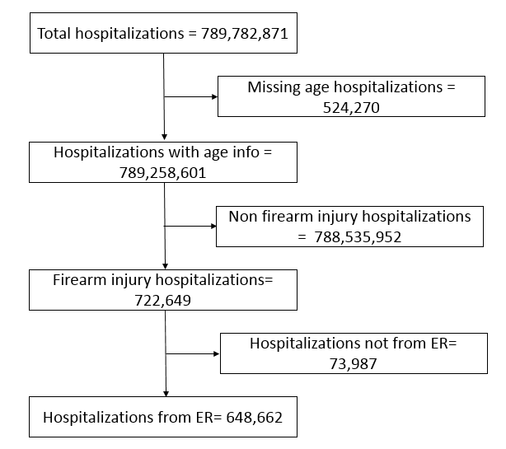

Supplementary Figure 2. Weighted stacked percentage of firearm injury hospitalization from 1993 to 2014 by age group
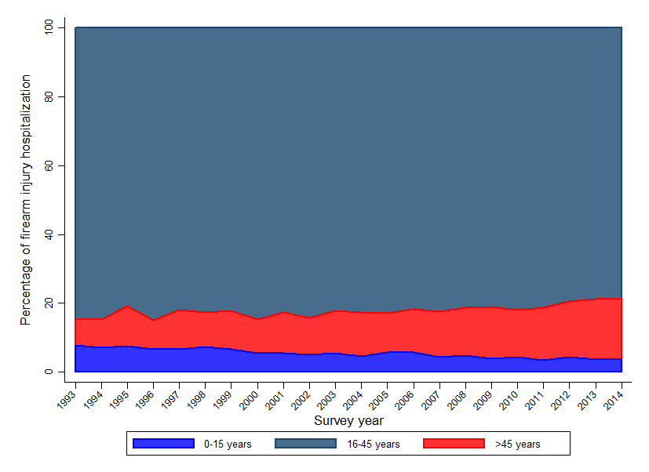

Supplementary Figure 3. Weighted stacked percentage of firearm injury hospitalization from 1993 to 2014 by sex
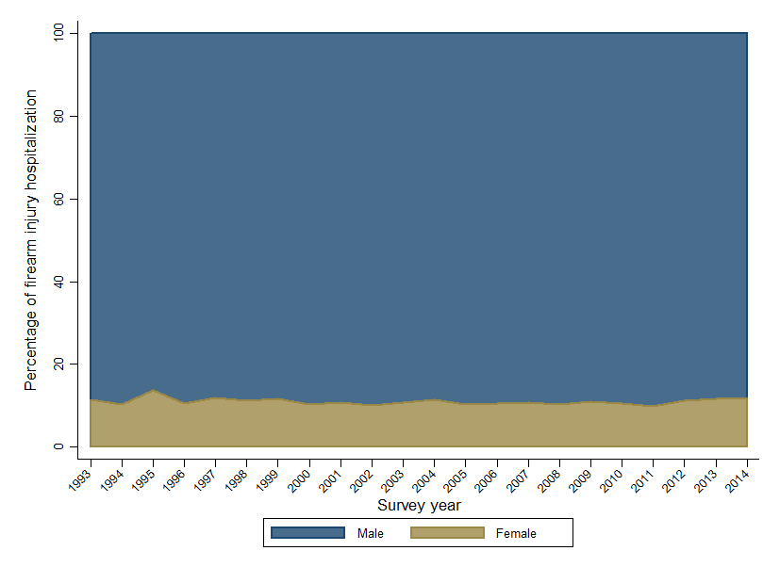

Supplementary Figure 4. Weighted stacked percentage of firearm injury hospitalization from 1993 to 2014 by intent
